AFADZATO SOUTH DISTRICT ASSEMBLY


ANNUAL PROGRESS REPORT

JANUARY - DECEMBER, 2023

Prepared by:
District Planning Co-ordinating Unit
Afadzato South District Assembly
Ve - Golokuati

FEB, 2024

TABLE OF CONTENT
TABLE OF CONTENT i
LIST OF TABLES ii
LIST OF FIGURES iii
LIST OF ACRONYMS iv
EXECUTIVE SUMMARY v
CHAPTER ONE 1
GENERAL INTRODUCTION 1
1.1 Introduction 1
1.1.1 Vision 1
1.1.2 Mission 2
1.2 Summary of Achievement and Challenges with the Implementation of the 2023 AAP and MTDP 2022-2025 2
1.2.1 Summary of Achievements 2
1.2.2 Challenges Encountered 5
1.3 Purpose of the Monitoring and Evaluation 5
1.4 Processes Involved and Difficulties Encountered 6
1.4.1 Processes Involved 6
1.4.2 Difficulties Encountered 6
CHAPTER TWO 7
MONITORING AND EVALUATION ACTIVITIES 7
2.1 Introduction 7
2.2 Status of Programmes and Projects 7
2.2.1 Status of Project Implementation 7
2.2.2 Repairs and Maintenance of Existing Infrastructure 10
2.2.3 Status of Programme Implementation 11
2.3 Update on Funding Sources and Disbursements 17
2.3.1 Revenue Mobilization 17
2.3.2 Expenditure Management 18
2.3.3 Capital Expenditure Analysis 19
2.4 Update on Indicators and Targets 21
2.5 Update on Critical Development and Poverty Issues 27
2.6 Human Resource Capacity 28
2.7 Human Resource Development 29
2.8 Logistics Capacity and Functionality 29
2.9 Evaluations Conducted, Findings and Recommendations 30
2.10 Participatory Monitoring and Evaluation (PM&E) Undertaken and Results 31
CHAPTER THREE 34
THE WAY FORWARD 34
3.1 KEY ISSUES ADDRESSED AND THOSE YET TO BE ADDRESSED 34
3.1.1 Key Issues Addressed 34
3.1.2 Key Issues yet to be addressed 34
3.2 Recommendations 34
3.3 Conclusion 35
Annex: Project Photos 36

LIST OF TABLES
Table 1: Details on the Annual Action Plan Implemented 3
Table 2: Proportion of the DMTDP implemented 4
Table 3: Project Register 8
Table 4: Repair and maintenance of existing infrastructure 10
Table 5: Programme Register 11
Table 6: Update on Revenue Sources 18
Table 7: Update on Expenditure 19
Table 8: MMDAs Capex Analysis, 2023 19
Table 9: CAPEX budget allocation and implementation for active projects 20
Table 10: Performance of District Indicators 21
Table 11: Update on Critical Development and Poverty Issues 27
Table 12: Staff Strengths 28
Table 13: Staff Capacity Building 29
Table 14: Logistics Analysis 30
Table 15: Update on evaluations conducted 32
Table 16: Update on Participatory Monitoring and Evaluation (PM&E) Conducted 32

LIST OF FIGURES
Figure 1: 2022 and 2023 AAPs Performance 3
Figure 2: Proportion of MTDP Implemented 4

LIST OF ACRONYMS
AAP Annual Action Plan
APR Annual Progress Report
ASDA Afadzto South District Assembly
CBOs Community Based Organizations
CPESDP Coordinated Programme of Economic and Social Development Policies
CLTS Community-Led Total Sanitation
CSO Civil Society Organization
DACF District Assembly Common Fund
DCD District Coordinating Director
DCE District Chief Executive
DDF District Development Facility/Fund
DED District Education Directorate
DFO District Finance Officer
DM&E District Monitoring and Evaluation
DMTDP District Medium-Term Development Plan
DPCU District Planning and Co-ordinating Unit
DPO District Planning Officer
DDA District Department of Agriculture
DPMD Disaster Prevention and Management Department
GHS Ghana Health Service
GES Ghana Education Service
GPSNP Ghana Productive Safety Net Project
GSFP Ghana School Feeding Programme
LEAP Livelihood Empowerment against Poverty
LIPW Labour Intensive Public Works
MMDAs Metropolitan, Municipal and District Assemblies
MOFA Ministry of Food and Agriculture
M&E Monitoring and Evaluation
MTDP Medium Term Development Plan
NABCO Nation Builders Corps
NDPC National Development Planning Commission
NGOs Non- Governmental Organizations
PERD Planting for Export and Rural development
PFJ Planting for Food and Jobs
PPE Personal Protective Equipment

EXECUTIVE SUMMARY
In accordance with the terms of the Local Governance, 2016, (Act 936), the Metropolitan, Municipal, and District Assemblies (MMDAs) are mandated to plan, mobilize revenue, and implement development programs in their respective jurisdictions. As a result, MMDAs are required to design development plans, implement those plans, and monitor and assess the activities, projects, and programs included in those plans in order to ensure that those activities, initiatives, and programs achieve the desired results.
This APR is done on the basis of the of status of indicators and targets used for monitoring and evaluating the achievements of activities/interventions planned for the time period under review. It also emphasizes key physical project activities that took place during the period under consideration in order to bring about the desired changes in the people's lives.
The report is presented in three chapters. Chapter one presents an introduction which entails the summary of achievements and challenges with the implementation of the 2023 Annual Action Plan, the purpose of the M&E activity for the year, processes involved as well as challenges encountered. Chapter two contains programmes and projects register, updates on funding sources and disbursements, updates on indicators and targets as well as updates on critical development and poverty issues. Also presented here include findings and recommendations on development evaluations conducted during the year and findings and recommendations on participatory monitoring and evaluations conducted. Chapter Three focused on key issues addressed and those yet to be addressed as well as recommendations for the way forward.
The report revealed that, the AAP for 2023, as presented on Table 1, contained Ninety-Four (94) activities, projects and programmes. A total of Eighty-Five (85) of the activities/programmes in the AAP were implemented, representing 90.4%.
It is revealed that, the Assembly targeted a total sum of Six Million, Four Hundred and Two Thousand, Two Hundred and Ten Cedis, Forty-Five Pesewas (GHC 6,402,210.45) for the year, 2023. However, the Assembly received Two Million, Six Hundred and Thirty-Four Thousand, Seven Hundred and Fifty-Six Ghana Cedis, Sixteen Pesewas (GHC2,634,756.16), representing 41.15% of the total revenue target for the year.

CHAPTER ONE

INTRODUCTION

1.1 BACKGROUND
The Metropolitan, Municipal and District Assemblies (MMDAs) are officially mandated, to plan, mobilize revenue and implement development programmes in their respective jurisdictions in accordance with the provisions of the Local Governance, 2016 (Act 936). In line with the above objective, MMDAs are mandated to prepare their development plans, prosecute such plans, monitor and evaluate the activities and programmes in those plans as a way of ensuring that those activities, projects and programmes achieve the desired outcome.
As part of its responsibility to ensure the District's all-inclusive development, the Afadzato South District Assembly (ASDA) has been implementing a four-year Medium Term Development Plan (MTDP) under the Medium-Term National Development Policy Framework (MTNDPF); Agenda for Jobs: Creating Prosperity and Equal Opportunities for All. It's the seventh in a series of development policy frameworks that have been developed over the last two decades. The framework builds on the successes of its immediate predecessor, the Ghana Shared Growth and Development Agenda (GSGDA) II, which was implemented from 2014 to 2017.
The purpose of the MTNDPF is to operationalize the vision, policies and programmes outlined in the President’s Coordinated Programme of Economic and Social Development Policy (CPESDP). This medium-term national development policy framework, 2022-2025, becomes the guide as far as the overall economic and social development of the District was concerned.
The implementation of the Annual Action Plan (AAP) for 2023 took into account topics such as the Sustainable Development Goals (SDGs), the African Union Agenda 2063, and the Paris Climate Change Agreement (COP21). The plan was carried out in accordance with the six (6) main Development Dimensions outlined below:
1. Economic development;
2. Social development;
3. Environment, infrastructure and human settlements;
4. Governance, corruption and public accountability
5. Emergency Planning and Response (Including Covid-19 Recovery Plan)
6. Implementation, Coordination, Monitoring and Evaluation

1.1.1 Vision
The Afadzato South Assembly has a vision to become the epitome of sustainable development and a first-class District Assembly in Ghana. This vision plays significant role in planning and administrative activities of the district.

1.1.2 Mission
The Afadzato South District Assembly exists to improve both social and economic life of her people through efficient and effective resource mobilization, maintaining a strong agricultural base for further industrial development, being a leading tourist Centre in Ghana and preserving cultural heritage of her people and the Region at large.

1.2 Summary of Achievement and Challenges with the Implementation of the 2023 AAP and MTDP 2022-2025
Activities and programmes of the AAP for 2023 were taken out of the 2022-2025 MTDP of the Assembly. The Assembly also focused more on climate change through the establishment of a 60 acre (30-acre coconut with nursery, 30-acre oil-palm) in the district. Also, it embarked on sustainable agriculture, HIV/AIDS issues, Support to persons living with Disability, Livelihood Empowerment Against Poverty (LEAP), strengthening Assembly structures, security, water and sanitation, educational service delivery and completion of on-going projects. Also, government’s flagship programmes including Planting for Food and Jobs (PFJ), as well as the Ghana Productive Safety Network Project (GPSNP) were some of the activities and programmes undertaken by the Assembly.
The AAP for 2023, as presented on Table 1, contained Ninety-Four (94) activities, projects and programmes. A total of Eighty-Five (85) of the activities/programmes in the AAP were implemented, representing 90.4%. Nine (9) No. physical projects were on-going. The Table 1 below shows a summary of the achievements of the 2023 action plan.
Table 1: Details on the Annual Action Plan implemented
SN | D/2evelopment Dimension | 2022 |  | 2023
SN | D/2evelopment Dimension | Plan | Exec | Plan | Exec
1. | Economic development | 19 | 18 | 15 | 13
2. | Social development | 29 | 27 | 32 | 30
3. | Environment, infrastructure & human settlements | 18 | 16 | 13 | 11
4. | Governance, corruption and public accountability | 23 | 21 | 26 | 24
5. | Emergency Planning and Response | 7 | 5 | 3 | 3
6. | Implementation, Coordination, Monitoring and Evaluation | 5 | 4 | 5 | 4
 | TOTAL | 101 | 91 | 94 | 85
DPCU Analysis, January 2024
It is shown on Table 1 that, a total of 101 programmes/projects/activities were planned for in 2022 out of which 94 activities were executed, signifying 90.1%. For the year under review, a total of 85 activities were implemented out of a total planned activity of 94, representing 90.4%. A graphical representation of the performance of the 2022 and 2023 AAPs is presented on Figure 1 below.
Figure 1: 2022 and 2023 AAPs Performance

Table 2: Proportion of the DMTDP implemented
Indicators | Baseline  2021 | Actual  2022 | Target  2023 | Actual  2023
1. Proportion of the annual action plan implemented by the end of the year  a. Percentage completed  b. Percentage of ongoing interventions  c. Percentage of interventions abandoned  d. Percentage of interventions yet to start | 91.6%  47.8%  35.6%  8.2%  8.4% | 90.1  45.1%  38.3%  6.7%  9.9% | 90%  45.0%  40.0%  5.0%  10.% | 90.4%  40%  40.4%  10%  9.6%
2. Proportion of the overall medium-term development plan implemented | 22.5% | 22.5% | 46% | 45.1%
DPCU Analysis, February 2024
Shown on Figure 2 is the percentage of 2023 MTDP executed. The achievement of 22.5% in 2021 serves as the baseline for the 2022-2025 MTDP. It is indicated that 22.5 percent of activities of the the MTDP was implemented during the first year (2022). Furthermore, about the same percentage (22.6%) was achieved in 2022, thus 45.1% cumulatively in 2023. Achievement included completed and ongoing interventions.
Figure 2: Proportion of MTDP Implemented
DPCU Analysis, February 2024

1.2.2 Challenges Encountered
- Inadequate capacity of personnel for M&E activities.
- Lack of vehicle for Monitoring and Evaluation.
- DPCU encountered challenges with data collection during the exercise but, due to effective co-ordination, the report was carried out successfully.
- Limited financial resources for effective Monitoring and Evaluation of DMTDP.
- Lack of appropriate logistics for performing M&E activities in the District.
- Delays in submission of Departmental Reports as inputs into the compilation of the Quarterly/Annual Progress Reports and inconsistencies in the reporting format over the years.

1.3 Purpose of the Monitoring and Evaluation
Monitoring and Evaluation (M&E) of the DMTDP and reporting will show the extent of progress made towards the implementation of the Action Plan/MTDP and will further help to:
- Assess whether DMTDP developmental targets were being met.
- Document lessons learnt from the implementation of programmes and projects.
- Improve service delivery and influence allocation of resources in the District.
- Give stakeholders a sense of ownership of development programmes.
- Identify achievements, constraints and failures so that improvements can be made to the DMTDP and project designs to achieve better impact.
- Identify the appropriate interventions that will increase the responsiveness of targeted beneficiaries.
- Demonstrate result to stakeholders as part of accountability and transparency.

1.4 Processes Involved and Difficulties Encountered

1.4.1 Processes Involved
The monitoring team of the Assembly lead by the District Planning Coordinating Unit (DPCU), undertook quarterly monitoring visits to project sites. At the various project sites, the team was joined by Assembly Members, Chiefs, Opinion Leaders and managers of said projects. The various contractors were made to meet the team on each visit.

The Works Department conducted their routine inspection of implementing projects. Their observations are put together in the form of individual project reports which feed into the composite progress report. Verification reports are also prepared by a five-member team namely, Planning, Budget, Internal Audit, Works and Assembly Members of electoral areas that have project located. Summary reports are then prepared before payments are effected.

Departments such as Education, Health among others and the Works sub-Committee were involved in monitoring of the projects, be it physical on non-physical. There are instances where external bodies also undertake monitoring on projects of interest to them. Examples are the Regional Coordinating Council (RCC) and the Office of the Administrator of DACF among others.

The process also involved holding of mid-year review meetings, assessment of set indicators and follow-ups where necessary. These review meetings are held with other non-DPCU members who are stakeholders such as State Owned Organizations, Traditional Authority etc.

The Assembly relies on the DPCU for undertaking Participatory Monitoring and Evaluation (PM&E) in the District. This team comprises of all relevant stakeholders both the primary and secondary stakeholders and this team visited project sites quarterly.

1.4.2 Difficulties Encountered
Among the difficulties encountered by the District Assembly in the implementation of the MTDP as well as preparation of Annual and Quarterly monitoring and evaluation reports have been outlined below:
- Delay in finalization and submission of departmental reports
- Some departments complained about the late release of funds for planned projects hence their inability to execute their activities on time.
- Inconsistencies in reports from some departments

CHAPTER TWO

MONITORING AND EVALUATION ACTIVITIES

2.1 Introduction
Monitoring and evaluation is an indispensable exercise in the implementation of the DMTDP. It enables the District to assess the level of achievement of developmental targets, identify constraints and failures and suggest ways of improving project designs to achieve better impact. This chapter, therefore, entails the status of projects, disbursement of funds, indicators and targets of the MTDP, development and poverty issues, evaluations conducted and participatory M&E undertaken during the year under review.
2.1 Status of Development Project/Programme Implemented (January – December, 2023)
An analysis of the year revealed that The Assembly also focused more on climate change through the establishment of a 60 acre (30-acre coconut with nursery, 30-acre oil-palm) in the district. as well as educational projects (provision of furniture) to improve access to education and learning. Projects for implementation in the previous year that were not completed were, as usual, rolled over and few new ones were also added for implementation during the period under review. The assessment showed better achievement with the DPAT funded physical projects, but moderate with that of the DACF. Some of the decentralized departments also played their part in the implementation of non-physical projects considerably.

Table 3: Project Register
Project Description |  | Development Dimension | Location | Contractor | Contract Sum  GH¢ | Date of Award | Source of Funding | Date Started | Expected Date of Completion | Expenditure to Date  GH¢ | Out Standing Balance  GH¢ | Implementation Status |  | Strategies to Improve Project Completion Rate | How Citizens were involved in monitoring of works contract | Remarks Summary on land acquisition and resettlement
Code | Name |  |  |  |  |  |  |  |  |  |  | % | pic | Strategies to Improve Project Completion Rate | How Citizens were involved in monitoring of works contract | Remarks Summary on land acquisition and resettlement
 | 1. Construction of 1No. 10 - Seater Water Closet Toilet with ancillary facilities | Social Development | Wudome | Sam - Ans Limited | 186,493.69 | 12/10/2016 | MP DACF | 19/10/2016 | 7/12/2023 | 138,751.45 | 50,975.17 | 80% | Ongoing | NA | Site meeting | Assembly acquired land from traditional leaders
 | 2. Construction of 1No. 3 -Unit Classroom block with ancillary facilities | Social Development | Leklebi - Dafor | Right First Time Ltd | 323,610.65 | 4th June, 2019 | DACF | 21st Jun, 2019 | 21st Sep, 2023 | 242,692.78 | 113,329.66 | 85% | Ongoing | NA | Site meeting | Assembly acquired land from traditional leaders
 | 3. Construction of 1No. 3-Unit Classroom Block with ancillary facilities | Social Development | Sadzikope | Proximi-ty Dev. Group Ltd | 380,758.44 | 9/07/2020 | DACF | 23/07/2020 | 09/12/2023 | 57,113.77 | 323,644.67 | 80% | Ongoing | NA | Site meeting | Assembly acquired land from traditional leaders
 | 4. Construction of 1No. ICT Centre | Social Development | Ve-Deme | S. P. K. Kosap | 297,930.63 | 9/07/2020 | DACF | 23/07/2020 | 07/12/2023 | 138,026.60 | 159,904.03 | 95% | Ongoing | NA | Site meeting | Assembly acquired land from traditional leaders
 | 5. Carry out reshaping (Routine Maintenance) of 8km community and school roads | Road & Transport | Selected communities | Visla Investment Ltd | 88,440.00 | 14/04/22 | DACF | 21/04/22 | 14/12/23 | 50,000.00 | 38,440.00 | 60% | Ongoing | NA | Site meeting | Assembly acquired land from traditional leaders
 | 6. Construction of 1 No. 2-Bedroom Semi-7. Detached Nurses | Social Development | Ve-Golokwati | Euwin Ltd | 455,000.38 | 6/08/2022 | DPAT V | 6/08/2022 | 26/12/2023 | 432,250.18 | 22,750.20 | 95% | Ongoing | NA | Site meeting | Assembly acquired land from traditional leaders
 | Carry out reshaping (Routine Maintenance) of 8km community and school roads | Social Development | Selected communities | Visla Investment Ltd | 88,440.00 | DACF | 14/04/22 | 21/04/23 | 14/06/22 | 50,000.00 | 38,440.00 | 70% | On-going |  | Site meeting | Road land & no resettlement required
 | 8. Construction of 1No. 4 bedroom Quarters for District Coordinating Director | Gove-rnance | Ve - Golokwati | Estate De - Royals Limited | 451,335.76 | 10th Apr. 2019 | DACF | 23rd Apr. 2019 | 23rd Jul. 2023 | 267,334.63 | 184,001.13 | 70% | On-going | NA | Site meeting | Assembly acquired land from traditional leaders
 | 9. Rehabilitation of Adzekope Junction – Adzekope Feeder Road (3.95km) | Social Development | Adzekope, | Sly Link Co. Ltd. | 347,944.65 | GPSNP | 31st May, 2023 | 31st June, 2023 | 31st April, 2024 | 0.00 | 347,944.65 | 10% | On-going | Social Development | Site meeting | Road land & no resettlement required

2.2.2 Repairs and Maintenance of Existing Infrastructure
The period under consideration saw some repair and maintenance woks carried out on key infrastructure and assets of the Assembly as stated in table 4. These assets include office equipment, vehicles, water systems, traffic lights, roads, office and residential buildings. The Assembly faced the challenge of inadequate and untimely release of fund thereby making it difficult to fully maintained its assets. It is recommended that management should set aside a percentage of the little available funds to undertake maintenance works on the assets since the Assembly needs these assets and infrastructure to achieve results.
Table 4: Repair and Maintenance of Existing Infrastructure
Asset/ infrastructure | Location | Type of maintenance | Estimated Cost GH¢ | Actual Release GH¢ | Gap  GH¢ | Expenditure  GH¢ | Recommendation
1. Maintenance of office Equipment | Ve-Golokuati | Repair of photocopier | 24,700.00 | 25,604.00 | 1,096.00 | 25,604.00 | Adequate funds should be released timely
2. Maintenance of Tractor 2No. | Ve-Golokuati | Vehicle |  | 3,713.00 | 16,6488.3 | 18,811.70 | Adequate funds should be released timely
3. Maintenance of official vehicles | Ve-Golokuati | Vehicle |  | 23,364.19 | 7,677.19 | 15,687.00 | Adequate funds should be released timely
4. Rehabilitation and mechanization of 4No.water systems | Ve-Golokuati | Water systems |  | 3,359.12 | 0.00 | 3,359.12 | Adequate funds should be released timely
5. Maintenance of feeder roads/opening of roads | Ve-Golokuati | Road |  | 16,000.00 | 0.00 | 16,000.00 | Adequate funds should be released timely

2.2.3 Status of Programme Implementation
Table 5 shows the programmes implemented under the various development dimensions by departments of the District Assembly. The period under review witnessed some delay and non-implementation of some programmes. This is largely due to insufficient and delay in release of funds. Thus, this affected timely execution of planned activities and programmes. There is a need for government to release operational funds of decentralized departments to ensure smooth running of the departments to enable them deliver on their mandate for the benefit of the people. Also, the Assembly should step up its revenue mobilization drive to generate more revenue for implementation of activities and programmes.
Table 5: Programme Register
PROGRAMME DESCRIPTION | DEVELOPMENT DIMENSION OF POLICY FRAMEWORK | AMOUNT INVOLVED SUM  GH¢ | SOURCE OF FUNDING | DATE STARTED | EXPECTED DATE OF COMPLETION | EXPENDITURE TO DATE  GH¢ | OUT STANDING BALANCE  GH¢ | IMPLEMENTATION STATUS |  | REMARKS  (NO. OF BENEFICIARIES)
 |  |  |  |  |  |  |  | % | Pic | REMARKS  (NO. OF BENEFICIARIES)
1. Implement hird phase of CLTS in the district | Social Development | 3000.00 | UNICEF | 03/10/23 | 29/09/23 | 3,000.00 | 0.00 | 100 | Completed | 10 communities
2. Water Sanitation and Hygiene (WASH) education in selected communities/schools | Social Development | 3,400.00 | UNICEF | 03/10/23 | 29/09/23 | 3,400.00 | 0.00 | 100 | Completed | 10 project communities
3. Supervision of zoom lion activities | Social Development | 1,500.00 | IGF | 03/10/23 | 29/09/23 | 1,500.00 | 0.00 | 100 | Completed | District wide
4. Organize routine cleansing of Central Business District, towns and other public places | Social Development | 2000.00 | IGF | 03/10/23 | 29/07/23 | 2000.00 | 0.00 | 100 | Completed | District wide
5. Conduct stray animal arrest exercise | Social Development | 1000.00 | IGF | 03/07/23 | 29/09/23 | 1,000.00 | 0.00 | 100 | Completed | Districtwide
6. Provision of logistics and relief items for effective operation of NADMO | Environment | 17,500.00 | DACF | 01/01/23 | 31/12/23 | 5,000.00 | 12,500.00 | 28 | Ongoing | NADMO
7. Collaboration of DA and National Fire Service for sensitization on bush fire in selected communities | Environment | 2,000.00 | DACF | 22/12/23 | 22/12/23 | 2,000.00 | 0.00 | 100 | Completed | 1,200
8. Embark on community sensitization on illegal chain sawing, bush fire/burning and sand winning | Environment | 3.000.00 | DACF | 01/10/23 | 31/12/2023 | 3.000.00 | 0.00 | 100 | Completed | Districtwide
9. Public Education on Windstorm/Rainstorm | Environment | 1,500.00 | IGF | 21/10/23 | 08/09/23 | 1,500.00 | 0.00 | 100 | Completed | 4 communities
10. Sensitization on the importance of tree planting | Environment | 0.00 | DACF | 02/10/23 | 31/12/23 | 0.00 | 0.00 | 100 | Completed | Districtwide
11. Implement the Ghana Productive Safety Net Project (GPSNP) – Maintenance of 110 Acre Climate Change oil-palm plantation | Environment | 79,372.29 | GPSNP | 01/10/23 | 31/12/2023 | 80,222.29 | 0.00 | 100 | Ongoing | 121
12. Rehabilitation of 6km feeder road etc. | Infrastructure | 600,000.00 | GPSNP | 01/01/23 | 31/12/23 | 450,000.00 | 150,000.00 | 75 | Ongoing | 3 selected communities
13. Rehabilitation of 10 No. boreholes | Infrastructure | 15,000.00 | DACF | 01/01/23 | 31/12/23 | 5,000.00 | 10,000.00 | 66 | Ongoing | Selected communities
12. Carry out Sanitation Improvement Package (SIP) & Fumigation activities | Social Development | 350,000.00 | DACF | 04/10/23 | 31/12/23 | 350,000.00 | 0.00 | 100 | Completed | Districtwide
14. Food safety and annual medical screening | Social Development | 1,500.00 | IGF | 03/07/23 | 29/09/23 | 1,500.00 | 0.00 | 100 | Completed | District wide  1,100 Persons Screened
15.Premises Inspection and Sanitary Regulation on Compliance Enforcement | Social Development | 1000.00 | IGF | 03/10/23 | 29/09/23 | 1,000.00 | 0.00 | 100 | Completed | 5 communities
16. Provide training for tour guides to strengthen the management system of existing tourists sites in the district | Economic Development | 8,000.00 | DACF | 02/01/23 | 03/04/23 | 8,000.00 | 0.00 | 100 | Completed
17. Participation in the 2023 Volta Trade and Investment Fair | Economic Development | 1,000.00 | DACF | 03/10/23 | 31/10/23 | 1,000.00 | 0.00 | 100 | Completed
16. Sensitize communities on sex tourism and how to handle tourists | Economic Development | 25,000.00 | DACF | 19/01/23 | 31/12/23 | 25,000.00 | 0.00 | 100 | Completed
18. Collaborate (provision of support) with Traditional authorities for the celebration of festivals | Economic Development | 8,500.00 | DACF | 01/01/23 | 31/12/23 | 8,500.00 | 0.00 | 100 | Completed
19. Conduct Business Counselling for entrepreneurs | Economic Development | 2,500.00 | GOG | 03/10/23 | 29/07/23 | 2,500.00 | 0.00 | 100 | Completed | 36 Beneficiaries
20. NVTI graduation held at Have | Economic Development | 1000.00 | DACF | 07/01/23 | 07/01/23 | 1000.00 | 0.00 | 100 | Completed | 7
21. Follow up on CAPBuSS Recovery | Economic Development | 30,000.00 | GOG | 03/10/23 | 29/09/23 | 10,000.00 | 0.00 | 35 | Ongoing | 15  Beneficiaries
19. Organization of Forum for a group of tailors and dressmakers | Economic Development | 1,000.00 | DACF | 02/01/23 | 31/01/23 | 1,000.00 | 0.00 | 100 | Completed | M-45  F-70  T-115
22. Distribution of Singer sewing machine to group of tailors and dressmakers | Economic Development | 1,500.00 | DACF/MASLOC | 19/01/23 | 19/01/23 | 1,500.00 | 0.00 | 100 | Completed | 150
23. Assist Clients to register with RGD/GEA | Economic Development | 4,000.00 | GOG | 03/10/23 | 29/07/23 | 4,000.00 | 0.00 | 100 | Completed | 1 Beneficiary
24. BAC collaboration with the Agric Department to train women in Tom brown making | Economic Development | 1,500.00 | IGF | 03/04/23 | 03/04/23 | 1,500.00 | 0.00 | 100 | Completed | 5 communities
25. Organise basic level Entrepreneurship training for selected Youstart Program at Ve-Golkuati | Economic Development | 3,000.00 | World Bank | 04/04/23 | 06/06/23 | 3,000.00 | 0.00 | 100 | Completed | 70 applicants
26. Ongoing intermediate Youstart training program for applicants comprising 20 from Hohoe Municipal Assembly BAC and 18 from Afadzato South BAC | Economic Development | 4,000.00 | World Bank | 12/06/23 | 16/06/23 | 4,000.00 | 0.00 | 100 | Complete  nnnnnnnnd | 38 applicants
27. Implement CLASS activities - Sensitization, self-selection, enrolment and training of Beneficiaries of GPSNP2-PI component | Environment | 24,000.00 | DACF | 04/10/23 | 31/12/23 | 2,100.00 | 0.00 | 100 | Completed | M-119  F-172  T-291
28. Organize home and farm visit under extension | Economic Development | 1000.00 | DACF | 01/01/23 | 31/12/23 | 1,000.00 | 0.00 | 100 | Completed | Districtwide
29. Organize data collection on rice yield | Economic Development | 2,500.00 | DACF | 03/04/23 | 31/12/23 | 2,500.00 | 0.00 | 100 | Completed | Districtwide
30. Conduct pest and disease surveillance | Economic Development | 4,500.00 | DACF | 03/04/23 | 31/12/23 | 4,500.00 | 0.00 | 100 | Completed | Districtwide
31. Training of women farmers on post-harvest management | Economic Development | 3,000.00 | DACF | 02/10/23 | 08/09/23 | 3,000.00 | 0.00 | 100 | Completed | Districtwide
32. Training of students on gardening | Economic Development | 1,500.00 | DACF | 01/10/23 | 31/10/23 | 1,500.00 | 0.00 | 100 | Completed | Selected Schools
33. Conduct field demonstra-tions for women FBOs to enhance adoption of new technology | Economic Development | 3,000.00 | DACF | 01/01/23 | 31/12/23 | 3,000.00 | 0.00 | 100 | Completed | Districtwide
34. Provide the needed veterinary services and support to poultry and livestock livestock farmers | Economic Development | 1,120.00 | MAG | 01/01/23 | 31/12/23 | 1,120.00 | 0.00 | 100 | Completed | Districtwide
35. Conduct annual crops and livestock data and survey and market data | Economic Development | 1000.00 | DACF | 01/01/23 | 31/12/23 | 1000.00 | 0.00 | 100 | Completed | Districtwide
36. Training of women on nutrition, HIV/AIDs, branding and value addition of product. | Economic Development | 6,000.00 | GASIP | 01/01/23 | 29/09/23 | 6,000.00 | 0.00 | 100 | Completed | Districtwide
37. Implementation of Govt. flagship programmes and interventions (PFJ, MAG, WIAD and other initiatives) | Economic Development | 10,000.00 | DACF | 01/01/23 | 31/12/23 | 10,000.00 | 0.00 | 100 | Completed | Districtwide
38. Supply of broiler’s to (60% Female) farmers under ESRF project | Economic Development | 3,000.00 | ESRF | 21/10/23 | 22/10/23 | 3,000.00 | 0.00 | 100 | Completed | 60% female, 40% male
39. Sensitization of Foster Parenting in 10 churches and 5 mosque | Social Development | 3,000.00 | UNICEF | 10/02/23 | 17/02/23 | 3000.00 | 0.00 | 100 | Completed | 979
40. Implementation of the School Feeding Program in the district | Social Development | 3,000.00 | DACF | 01/01/23 | 31/01/23 | 3,000.00 | 0.00 | 100 | Completed | M-5,962  F-5,660  T-11,622
41. Celebration of key national events (Farmers’ Day, Independence Day, World AIDS Day etc) | Social Development | 98,100.00 | DACF | 06/03/23 | 31/12/23 | 98,100.00 | 0.00 | 100 | Completed | District Wide
42. Execute family welfare and child right protection awareness and case management (Foster parenting, Training of CC PC, child abuse, case maintenance etc.) | Social Development | 1100.00 | GOG | 01/10/23 | 24/06/22 | 12,600.00 | 0.00 | 100 | Completed | 1,765
43. Form and train Water and Sanitation Management Teams and Committees | Social Development | 10,000.00 | Plan Ghana | 01/10/23 | 31/12/2022 | 10,000.00 | 0.00 | 100 | Completed | Carried out
44. Organization of PWDs activities (Meeting to disburse PWDs funds and update data on PWDs etc) | Social Development | 150,000.00 | DACF | 01/01/23 | 31/12/23 | 150,000.00 | 0.00 | 100 | Completed | District Wide
45. Provide financial support to students, pupils and Persons with Special Needs in the form of scholarship/ award schemes | Social Development | 30,000.00 | MP/ DACF | October,2023 | December, 2023 | 30,000.00 | 0.00 | 100 | Completed | 20
46. Education of apprentices on the health and social effects of un-wanted pregnancies | Social Development | 1,000.00 | DACF | 01/05/23 | 03/05/23 | 1,000.00 | 0.00 | 100 | Completed | M- 24  F-75  T-99 Participants
47. Implement LEAP Programme to cover more communities (Monitoring of LEAP beneficiaries, payments etc) | Social Development | 96,600.00 | GOG | 21/10/23 | 21/12/23 | 96,600.00 | 0.00 | 80 | On going | 483 Households  M-147  F-336
48. Sensitization of 10 communities on child neglect and abuse | Social Development | 2,400.00 | UNICEF | 24/11/2023 | 28/11/2023 | 2,2400.00 | 0.00 | 100 | Completed | M-371  F-601  T=972
49. Education in 8 churches on positive/good parenting skills | Social Development | 3,840.00 | UNICEF | 02/10/2023 | 07/10/2023 | 3,840.00 | 0.00 | 100 | Completed | M-274  F-459  T=733
50. Follow up on reunified children with their families from Volta Home and EUGEMOT | Social Development | 1,260.00 | UNIICEF | 11/12/2023 | 14/12/20231 | 1,260.00 | 0.00 | 100 | Completed
51. Training of 20 community Child Protection Committee members in case management | Social Development | 4,100.00 | UNICEF | 23/10/2023 | 31/10/2023 | 4,100.00 | 0.00 | 100 | Completed | M-11  F-9  T=20
52. Carry out Street Naming and Digital Property Addressing System | Social Development | 3,000.00 | DACF | 08/10/23 | 08/12/23 | 3,000.00 | 0.00 | 60 | On going | District Wide
53. Organize public education on tax payment and mobilise revenue | Governance | 5,000.00 | DACF | 01/01/2023 | 31/12/2023 | 6,000.00 | 0.00 | 80 | On going | District wide
54. Outsource portions of revenue collection to the private sector | Governance | 3,000.00 | DACF | 01/01/2023 | 31/12/2023 | 3,000.00 | 0.00 | 80 | On going | Ve-Golokwati
55. Conduct SME Quarterly Committee meeting | Governance | 3,500.00 | DACF | 10/10/2023 | 10/10/2023 | 3,500.00 | 0.00 | 100 | Completed | Ve-Golokwati
56. Carry out development control activities (building control, supervision and permitting) | Governance | 2,500.00 | DACF | October, 2023 | December, 2023 | 2,500.00 | 0.00 | 45 | On going | District wide
57. Provide road safety signage at designated spots (Markets, schools, clinics etc) | Governance | 3,000.00 | DACF | 07/10/23 | 31/12/23 | 3,000.00 | 0.00 | 50 | On going | Districtwide
58. Organize statutory and other meetings (Gen. Assembly, Sub-Commit-tees, Mgt, DPCU, Budget Committee, Entity Tender, DISEC, Internal Audit Committee, PRCC, Technical Sub-Committee etc. | Governance | 9,000.00 | DACF | 01/10/23 | 31/12/23 | 150,000.00 | 0.00 | 100 | Completed | Female=2  Male=16
59. Conduct Participatory M&E (Formulate check-list for team to carry out the PM&E) | Implementa-tion, Coordi-nation, M&E | 3,000.00 | DACF | 01/10/23 | 31/12/23 | 5,000.00 | 10,000.00 | 100 | Completed
60. Prepare reports and submit to VRCC and NDPC ((Annual/ Quarterly Progress Reports) | Implementa-tion, Coordi-nation, M&E | 2,000.00 | DACF | 01/01/23 | 31/12/23 | 1,500.00 | 500.00 | 100 | On going
61. Conduct field visit to monitor and inspect projects of the DA | Implementa-tion, Coordi-nation, M&E | 20,000.00 | DACF | 01/10/23 | 31/12/23 | 6,700.00 | 13,300.00 | 100 | Completed
62. Organize Site Meetings of on-going projects | Implementa-tion, Coordi-nation, M&E | 3,000.00 | DACF | 01/10/23 | 31/12/23 | 2,000.00 | 4,000.00 | 100 | Completed | District wide
63. Prepare reports and submit to VRCC and NDPC ((Annual/ Quarterly Progress Reports) | Implementation, Coordi-nation, M&E | 1,000.00 | DACF | 01/10/23 | 31/12/23 | 500.00 | 1,500.00 | 100 | Completed | District wide
Source: DPCU, ASDA, 2023. *GPSNP – Ghana Productive Safety Net Project. * WIAD – Women In Agricultural Development.

2.3 Update on Funding Sources and Disbursements
Generally, the Assembly’s ability to implement development programmes/projects/activities is based on availability of funds. The major sources of revenue are basically from internal and external sources which include, Internally Generated Funds (IGF), District Assembly Common Fund (Act 455), Special Central Government grants (DDF, GETFund etc) and Central Government direct support.
The Table below shows the details of the Revenue status of the Assembly as at the end of December 2023.

2.3.1 Revenue Mobilization
The various revenue funding sources, targets and respective amounts received by the Assembly as at December, 2023 are presented on Table 6 below. It is shown on the Table 6 that, the Assembly targeted a total sum of Six Million, Four Hundred and Two Thousand, Two Hundred and Ten Cedis, Forty-Five Pesewas (GHC 6,402,210.45) for the year, 2023. During the end of the year, the Assembly received Two Million, Six Hundred and Thirty-Four Thousand, Seven Hundred and Fifty-Six Ghana Cedis, Sixteen Pesewas (GHC2,634,756.16), and representing 41.15% of the total revenue target for the year. Also, Table 6 reveals that, an amount of the IGF generated as at December, 2023 was GHC225,365.93, which accounted for 77.45% of the IGF target of GHC290,951.32. Thus, the revenue target for IGF for the year under review was not achieved and could be attributable to inadequate logistics for revenue mobilization and collection. This affected the level of implementation of activities during the year.

Table 6: Update on Revenue Sources
Revenue Sources | Estimates (GH¢) |  |  | Performance (GH¢)
Revenue Sources | 2021 | 2022 | 2023 | 2021 | 2022 | 2023
IGF | 242,459.97 | 290,951.32 | 320,046.45 | 215,593.26 | 298,140.99 | 225,365.93
DACF | 4,504,997.00 | 7,238,667.46 | 7,625.043.55 | 842,008.28 | 1,829,243.49 | 1,272,689.08
MP's CF | 1,031,250.00 | 1,031,250.08 | 1,031,250.00 | 294,652.01 | 363,889.98 | 476,544.89
PWDs CF | 350,000.00 | 350,000.00 | 350,000.00 | 96,644.71 | 216,323.33 | 169,912.98
MSHAP | - | 36,375.22 | 32,295.00 | 2,221.73 | 17,958.99 | 9,627.52
DDF/DPAT | 1,473 ,933.00 | 1,694,163.00 | 1,705,304.00 | 871,376.00 | 1,134,512.80 | 0.00
GPSNP | 808,560.00 | 800,000.00 | 800,000.00 | 76,301.60 | 79,372.29 | 382,320.00
GoG | 89,918.00 | 1,410,888.47 | 2,004,350.00 | 62,666.92 | 34,461.25 | 41,001.43
MAG | 150,500.00 | 43,980.48 | 50,000.00 | 61,353.64 | 43,980.48 | 32,294.33
UNICEF/DACF RESERVE | 110177.92 | 158,964.92 | 108,965.00 | 20,000.00 | 12,500.00 | 25,000.00
Total | 8,761,795.89 | 13,055,241.00 | 6,402,210.45 | 2,554,818.21 | 4,030,383.60 | 2,634,756.16
Source: Source: Budget Unit, ASDA, 2023

2.3.2 Expenditure Management
Presented on Table 7 is the expenditure performance for the period under review. It is shown that most of the expenditure was incurred on employees’ Compensation, followed by Goods and Services and CAPEX accounting for 49.1%, 36.4% and 14.5% respectively. This means that greater of the funds was spent on compensation instead of on funding programmes of departments and that of capital projects for the development of the district. This could be attributed to delayed and inadequate release of funds for implementation of capital projects of the Assembly. Management needs to strategise towards generation of more revenue internally to supplement that of the government’s in order that prioritised projects could be implemented for the development of the district. It could also be observed that the funds approved of for the year was less than what was released and expended. This might be due to payment of an arrears of the previous year, 2022.
Table 7: Update on Expenditure
Expenditure Item | 2021 |  |  | 2022 |  |  | 2023
Expenditure Item | Approved GH¢ | Released GH¢ | Expenditure GH¢ | Approved GH¢ | Released GH¢ | Expenditure GH¢ | Approved GH¢ | Released GH¢ | Expenditure GH¢
Compensation | 1,526,157.69 | 2,533,773.77 | 2,533,773.77 | 1,575,159.47 | 1,803,044.72 | 1,803,044.72 | 2,054,350.00 | 3,890,023.86 | 3,890,023.86
Goods and Service | 4,916,275.00 | 3,904,661.88 | 3,904,661.88 | 13,101,607.87 | 5,245,459.39 | 5,245,459.39 | 9,370.012 | 2,884,651.30 | 2,884,651.30
CAPEX | 3,702,224.00 | 855,036.14 | 855,036.14 | 4,539,338.00 | 1,475,943.76 | 1,475,943.76 | 4,705,304.00 | 1,141,075.90 | 1,141,075.90
Total | 10,144,656.69 | 7,293,471.79 | 7,293,471.79 | 19,216,105.34 | 8,524,447.87 | 8,524,447.87 | 6,769,024.01 | 7,915,751.06 | 7,915,751.06
Source: District Finance Dept., December 2023

2.3.3 Capital Expenditure Analysis
It is realised from Table 8 that only an amount of GH¢61,524.22 was incurred on capital projects out of a capital expenditure unconstrained budget of GH¢8,805,304.00. Also, out of released capex budget of GH¢1,141,075.90, only GH¢61,524.22 was expended on capital projects. Table 9 shows details on the specific capital projects, showing estimated cost, expenditure, implementation duration, time overruns, completion status and whether they are built on properly acquired lands.
The low expenditure on capital projects seen from the data is partly because of insufficient and untimely release of funds to the Assembly. It is recommended that enough funds should be timely released to the Assembly to execute programmes and projects timeously to the benefit of the people. Also the Assembly should use released funds for its specific purpose.
Table 8: MMDAs Capex Analysis, 2023
Proposal |  | Release | Expenditure | Variations |  |  | Recommendations
Unconstrained Capex- plan (A) | Constrained Capex-budget (B) | (C) | (D) | (A-B) | (B-C) | C-D
8,805,304.00 | 4,705,304.00 | 1,141,075.90 | 61,524.22 | 4,100,000.00 | 3,564,228.10 | 1,079,557.68 | Sufficient funds should be released on time in order to execute programmes and projects.

Table 9: CAPEX Budget Allocation and Implementation for Active Projects
Multi-Year CAPEX throw forward |  |  |  | MTBF envelope |  |  | Performance |  | Details on Capital Projects 2023
Total Medium-Term Plan Estimate (plan) | Annual Estimate (plan) | Annual Estimate (plan) | Annual Estimate (plan) | Annual ceilings |  |  | Approved/Releases | Expenditure | Code | Name of project | Project age | Original estimated cost | Revised cost | Expenditure to date | Completion status |  | Time overruns | Land acquisition and resettlement
2025 | 2025 | 2024 | 2023 | 2025 | 2024 | 2023 | 2023 | 2023 |  |  |  |  |  |  | % | Comment
500,000.00 | 0.00 | 0.00 | 500,000.00 | 0.00 | 0.00 | 50,000.00.00 | 50,000.00 | 0.00 |  | 1. Rehabilitation of Adzekope Junction – Adzekope Feeder Road (3.95km) | 12month | 347,944.65 | 347,944.65 | 0.00 | 10% | Ongoing | 12 month | Public road and no resettlement required
200,000.00 | 0.00 | 0.00 | 200,000.00 | 0.00 | 0.00 | 40,000.00 | 40,000.00 | 0.00 |  | 2. Construction of 1No. 10 - Seater WC Toilet with ancillary facilities at Ve-Wudome | 12month | 186,493.69 | 186,493.69 | 138,751.45 | 80% | Ongoing | 22month | Assembly acquired land from traditional leaders
330,000.00 | 0.00 | 0.00 | 330,000.00 | 0.00 | 0.00 | 50,000.00 | 50,000.00 | 0.00 |  | 3.Construction of 1No. 3 -Unit Classroom block with ancillary facilities at Leklebi Dafor | 12month | 323,610.65 | 323,610.65 | 242,692.78 | 85% | Ongoing | 18month | Assembly acquired land from traditional leaders
400,000.00 | 0.00 | 0.00 | 400,000.00 | 0.00 | 0.00 | 50,000.00 | 50,000.00 | 0.00 |  | 4. Construction of 1No. 3-Unit Classroom Block with ancillary facilities at Sadikope | 12month | 380,758.44 | 380,758.44 | 57,113.77 | 80% | Ongoing | 15month | Assembly acquired land from traditional leaders
300,000.00 | 0.00 | 0,00 | 300,000.00 | 0.00 | 0.00 | 50,000.00 | 40,000.00 | 0.00 |  | 5. Construction of 1No. ICT Centre at Ve-Deme | 12month | 297,930.63 | 297,930.63 | 138,026.60 | 95% | Ongoing | 17months | Assembly acquired land from traditional leaders
90,000.00 | 0.00 | 0.00 | 90,000.00 | 0.00 | 0.00 | 50,000.00 | 50,000.00 | 20,000.00 |  | 6. Carry out reshaping (Routine Maintenance) of 8km community and school roads | 12month | 88,440.00 | 88,440.00 | 50,000.00 | 60% | Ongoing | 24months | Assembly acquired land from traditional leaders
500,000.00 | 0.00 | 0.00 | 500,000.00 | 0.00 | 0.00 | 22,750.00 | 22,750.00 | 0.00 |  | 7. Construction of 1 No. 2-Bedroom Semi-Detached Nurses | 12month | 455,000.38 | 455,000.38 | 432,250.18 | 95% | Ongoing | 23months | Assembly acquired land from traditional leaders
500,000.00 | 0.00 | 0.00 | 500,000.00 | 0.00 | 0.00 | 100,000.00 | 80,000.00 | 0.00 |  | 8. Construction of 1No. 4 bedroom Quarters for District Coordi-nating Director | 12month | 451,335.76 | 451,335.76 | 267,334.63 | 70% | Ongoing | 19months | Assembly acquired land from traditional leaders

2.4 Update on Indicators and Targets
Table 10 below indicates the performance of core district indicators for the period under review.

Table 10: Performance of District Indicators
SN | Indicator (Categorised by Development Dimension | Baseline (2021) | Actual 2022 | Target 2023 | Actual  2023 | Key programmes Undertaken during the year | Challenges encountered in the year | Policy recommendations
 | Economic Development |  |  |  |  | Extension services through farmer visits | Inadequate motorbikes and fuel | Provide motorbikes and fuel timely
1. | Total output in agricultural production  i. Maize  ii. Rice (milled),  iii. Millet  iv. Sorghum  v. Cassava  vi. Yam  vii. Cocoyam  viii. Plantain  ix. Groundnut  x. Cowpea  xi. Soybean  xii. Cocoa  xiii. Shea nut  xiv. Oil palm  xv. Cashew nut  xvi. Cotton  xvii. Cattle  xviii. Sheep  xix. Goat  xx. Pig  xxi. Poultry |  |  |  |  | Extension services through farmer visits | Inadequate motorbikes and fuel | Provide motorbikes and fuel timely
1. |  | 28,719 | 22,607 | 38,000 | 34,128 | Extension services through farmer visits | Inadequate motorbikes and fuel | Provide motorbikes and fuel timely
1. |  | 20,626 | 14,203 | 24,000 | 22,158 | Extension services through farmer visits | Inadequate motorbikes and fuel | Provide motorbikes and fuel timely
1. |  | NA | NA | NA | NA | Extension services through farmer visits | Inadequate motorbikes and fuel | Provide motorbikes and fuel timely
1. |  | NA | NA | NA | NA | Extension services through farmer visits | Inadequate motorbikes and fuel | Provide motorbikes and fuel timely
1. |  | 143,469 | 151,779 | 200,000 | 19,812 | Extension services through farmer visits | Inadequate motorbikes and fuel | Provide motorbikes and fuel timely
1. |  | 25,197 | 26,363 | 40,000 | 39,132 | Extension services through farmer visits | Inadequate motorbikes and fuel | Provide motorbikes and fuel timely
1. |  | 1,341 | 1,415 | 4,000 | 38,712 | Extension services through farmer visits | Inadequate motorbikes and fuel | Provide motorbikes and fuel timely
1. |  | 1,929 | 2,190 | 4,000 | 37,453 | Extension services through farmer visits | Inadequate motorbikes and fuel | Provide motorbikes and fuel timely
1. |  | NA | NA | NA | NA | Extension services through farmer visits | Inadequate motorbikes and fuel | Provide motorbikes and fuel timely
1. |  | NA | NA | NA | NA | Extension services through farmer visits | Inadequate motorbikes and fuel | Provide motorbikes and fuel timely
1. |  | NA | NA | NA | NA | Extension services through farmer visits | Inadequate motorbikes and fuel | Provide motorbikes and fuel timely
1. |  | NA | NA | NA | NA | Extension services through farmer visits | Inadequate motorbikes and fuel | Provide motorbikes and fuel timely
1. |  | NA | NA | NA | NA | Extension services through farmer visits | Inadequate motorbikes and fuel | Provide motorbikes and fuel timely
1. |  | NA | NA | NA | NA | Extension services through farmer visits | Inadequate motorbikes and fuel | Provide motorbikes and fuel timely
1. |  | NA | NA | NA | NA | Extension services through farmer visits | Inadequate motorbikes and fuel | Provide motorbikes and fuel timely
1. |  | NA | NA | NA | NA | Extension services through farmer visits | Inadequate motorbikes and fuel | Provide motorbikes and fuel timely
1. |  | 250 | 320 | 660 | 642 | Extension services through farmer visits | Inadequate motorbikes and fuel | Provide motorbikes and fuel timely
1. |  | 7,276 | 5,130 | 6,000 | 5,130 | Extension services through farmer visits | Inadequate motorbikes and fuel | Provide motorbikes and fuel timely
1. |  | 16,908  2,596  30,394 | 8,079  1,570  13,500 | 15,000  20,000  38,000 | 14,852  19,521  19,230 | Extension services through farmer visits | Inadequate motorbikes and fuel | Provide motorbikes and fuel timely
2. | Average productivity of selected crop (mt/ha):  i. Maize  ii. Rice  iii. Cassava  iv. Yam  v. Cocoyam  vi. Plantain |  |  |  |  | Extension services through farmer visits | Inadequate motorbikes and fuel | Provide motorbikes and fuel timely
3. | Percentage of arable land under cultivation | 19% | 21% | 31% | 33% | Extension services through farmer visits | Inadequate motorbikes and fuel | Provide motorbikes and fuel timely
4. | Number of new industries established  i. Agriculture,  ii. Industry,  iii. Service | 1 | 0 | 0 | 0 | Business counselling | Inadequate motorbikes and fuel | Business counselling and Provision of motorbikes and fuel timely
4. |  | 0 | 0 | 0 | 0 | Business counselling | Inadequate motorbikes and fuel
4. |  | 0 | 0 | 0 | 0 | Business counselling | Inadequate motorbikes and fuel
5. | Number of new jobs created  i. Agriculture  ii. Industry  iii. Service | 1,450 | 2,100 | 4,200 | 3,231 | Promotion of apprenticeship | Inadequate funds & logistics | Provide funds & logistics
5. |  | 0 | 0 | 0 | 0 | Promotion of apprenticeship | Inadequate funds & logistics | Provide funds & logistics
5. |  | 0 | 0 | 0 | 0 | Promotion of apprenticeship | Inadequate funds & logistics | Provide funds & logistics
6 | Percentage change in IGF | - | - | - | -
 | Social Development
7. | Net enrolment ratio  i. Kindergarten  ii. Primary  iii. JHS  iv. SHS | 95% | 44.9% | 95% | 92% | School feeding programme and regular supervision of teaching and learning | Inadequate funds & logistics | Provide funds & logistics
7. |  | 98% | 51.2% | 60% | 83.20% |  | Inadequate funds & logistics | Provide funds & logistics
7. |  | 98%  97.5% | 59.0%  82.7% | 65%  75% | 75.60%  73.4% |  | Inadequate funds & logistics | Provide funds & logistics
8. | Gender Parity Index  i. Kindergarten  ii. Primary  iii. JHS  iv. SHS | 1.02 | 1.1 | 1.1 | 1.0 |  | Inadequate funds & logistics | Provide funds & logistics
8. |  | 1.00 | 1.0 | 1.0 | 1.20 |  | Inadequate funds & logistics | Provide funds & logistics
8. |  | 1.1 | 1.7 | 1.0 | 1.10 |  | Inadequate funds & logistics | Provide funds & logistics
8. |  | 1.45 | 0.9 | 0.9 | 1.20 |  | Inadequate funds & logistics | Provide funds & logistics
9. | Completion rate  i. Kindergarten  ii. Primary  iii. JHS  iv. SHS | 98% | 96.1% | 97.2% | 63.40% |  | Inadequate funds & logistics | Provide funds & logistics
9. |  | 97% | 96.3% | 95.3% | 55.30% |  | Inadequate funds & logistics | Provide funds & logistics
9. |  | 94% | 63.9% | 65.9% | 50.60% |  | Inadequate funds & logistics | Provide funds & logistics
9. |  | 97% | 98.1% | 92.1% | 60.20% |  | Inadequate funds & logistics | Provide funds & logistics
10. | Pass rate  i. JHS  ii. SHS |  |  |  |  |  | Inadequate funds & logistics | Provide funds & logistics
11. | Proportion of health facilities that are functional  i. CHPS Compound  ii. Clinic  iii. Health Center  iv. Polyclinic  v. Hospital |  |  |  |  | Provision of hospital equipment | Inadequate funds & logistics | Provide funds & logistics
11. |  | 13 | 13 | 20 | 18 | Provision of hospital equipment | Inadequate funds & logistics | Provide funds & logistics
11. |  | 2 | 2 | 2 | 2 | Provision of hospital equipment | Inadequate funds & logistics | Provide funds & logistics
11. |  | 8 | 8 | 8 | 8 | Provision of hospital equipment | Inadequate funds & logistics | Provide funds & logistics
11. |  | 1 | 1 | 1 | 1 | Provision of hospital equipment | Inadequate funds & logistics | Provide funds & logistics
11. |  | 0 | 0 | 1 | 0 | Provision of hospital equipment | Inadequate funds & logistics | Provide funds & logistics
12. | Prevalence of malnutrition (institutional)  i. Wasting  ii. Underweight  iii. Stunting  iv. Overweight | 0  0  0  0 | 0  0  0  0 | 0  0  0  0 | 0  0  0  0 | Health promotion and education in school and communities | Inadequate funds & logistics | Provide funds & logistics
13. | Maternal mortality ratio (Institutional) | 0/100,000000 | 0/100,000 | 0/100,000 | 0/100,000 | Health promotion and education in school and communities | Inadequate funds & logistics | Provide funds & logistics
14. | Malaria case fatality (Institutional)  i. District total  ii. Under five years  iii. Women between 15-49 | 0 | 0 | 0 | 0 | Health promotion and education in school and communities | Inadequate funds & logistics | Provide funds & logistics
14. |  | 0 | 0 | 0 | 0 | Health promotion and education in school and communities | Inadequate funds & logistics | Provide funds & logistics
14. |  | 0 | 0 | 0 | 0 | Health promotion and education in school and communities | Inadequate funds & logistics | Provide funds & logistics
15. | Proportion of population who have tested positive for covid-19 | 35 | 0 | 0 | 0 | Health promotion and education in school and communities | Inadequate funds & logistics | Provide funds & logistics
16. | Proportion of population with valid NHIS card  i. Total  ii. Indigents  iii. Informal  iv. Aged  v. Under 18years  vi. Pregnant Women |  |  |  |  | Health promotion and education in school and communities | Inadequate funds & logistics | Provide funds & logistics
17. | Number of births and deaths registered  i. Birth (sex)  Male  Female  ii. Death (sex, age group)  Male  Female |  |  |  |  | Sensitisation in communities and health facilities | Inadequate funds & logistics | Provide funds & logistics
17. |  | 215  101  114  205  NA  NA | NA  NA  NA  168  NA  NA | 1,600  2,095  2,210  NA  NA  NA | 1,411  552  859  72  37  35 | Sensitisation in communities and health facilities | Inadequate funds & logistics | Provide funds & logistics
18. | Percent of population with sustainable access to safe drinking water sources  i. District  ii. Urban  iii. Rural | 70% | 69% | 90% | 80% | Provision of mechanised boreholes | Inadequate funds | Provide funds & logistics
18. |  | 70% | 69% | 90% | 80% | Provision of mechanised boreholes | Inadequate funds | Provide funds & logistics
19 | Proportion of population with access to improved sanitation services  i. District  ii. Urban  iii. Rural | 43% | 39.7% | 60% | 55.7% | Provision of mechanised boreholes | Inadequate funds | Provide funds & logistics
19 |  | NA | NA | NA | NA | Provision of mechanised boreholes | Inadequate funds | Provide funds & logistics
19 |  | 43% | 39.7% | 60% | 55.7% | Provision of mechanised boreholes | Inadequate funds | Provide funds & logistics
20. | Recorded cases of child abuse  i. Child trafficking  ii. Child labour  iii. Sexual abuse  iv. Emotional abuse  v. Neglect  vi. Early marriage  vii. Female genital mutilation  viii. Family-child separation |  |  |  |  | Community education on child protection | Inadequate funds & logistics | Provide funds & logistics
20. |  | 0  0  0  0  0  0  0  0 | 0  0  0  0  0  0  0  0 | 0  0  0  0  0  0  0  0 | 0  0  0  0  0  0  0  0 | Community education on child protection | Inadequate funds & logistics | Provide funds & logistics
21. | Percentage of road network in good condition  i. Total  ii. Urban  iii. Feeder | 70% | 73% | 80% | 75% | Reshaping | Inadequate funds & logistics | Provide funds & logistics
21. |  | 70% | 73% | 80% | 75% | Reshaping | Inadequate funds & logistics | Provide funds & logistics
22. | Percentage of communities covered by electricity  i. District  ii. Rural  iii. Urban |  |  |  |  | Extension of electricity with meters | Delay in receiving meters | Timely delivery of meters
22. |  | 70% | 72% | 80% | 72% | Extension of electricity with meters | Delay in receiving meters | Timely delivery of meters
22. |  | 70% | 72% | 80% | 72% | Extension of electricity with meters | Delay in receiving meters | Timely delivery of meters
23. | Reported cases of crime  i. Rape  ii. Armed robbery  iii. Defilement  iv. Murder  v. Drug trafficking  vi. Peddling  v. Drug abuse  vi. Domestic violence
24. | Number of communities affected by disaster  i. Bushfire  ii. Floods  iii. Wind/Rainstorm
24. |  | 1  14  - | 0  0  - | 0  0  - | 0  0  - | Community sensitisation | Inadequate funds & logistics | Provide funds & logistics
25. | Percentage of annual action plan implemented | 91.6% | 90.1% | 90% | 90.4% | GPSNP support programme | Inadequate funds & logistics | Provide funds & logistics

2.5 Update on Critical Development and Poverty Issues
Afadzato South District is poised to reducing poverty and enhancing living conditions of its people. Some critical development and poverty intervention programmes implemented in the district are reported in Table 11 below.

Table 11: Update on Critical Development and Poverty Issues
Critical Development and Poverty Issues | Allocation GH¢ | Actual receipt GH¢ | No of beneficiaries
Critical Development and Poverty Issues | Allocation GH¢ | Actual receipt GH¢ | Targets | Actuals
Ghana School Feeding Programme | - | - | 11,379 pupils | 11,356 pupils made up of 5,856 males and 5,500 females
Capitation Grants | - | - | NA | The district did not benefit from this programme
National Health Insurance Scheme | - | - | 108,852 subscribers | 81,150 active subscribers made up of 41% males and 59% females
Livelihood Empowerment Against Poverty (LEAP) programme | 554,066.00 | 554,066.00 | 483 households | 483 Households benefited, 147 males and 336 females
Youth Employment Program | N/A | N/A | 117 youth | 117 beneficiaries
Free SHS Programme | - | - | 5,627 students | 3,383 males and 2,244 females students benefited from the programme
MAG / Planting for food and jobs programme | 41,000.00 | 41,000.00 | 15,000 farmers | 13,124 comprising 836 males and 4,288 females benefited from the programme
Ghana Productive Safety Net Project (GPSNP) 2 – Maintenance of 110 Acre Climate Change oil-palm plantation | 800,000.00 | 382,320.00 | 328 | 60.3% females and 39.7% males

2.6 Human Resource Capacity
One of the resources required for effective functionality of the Assembly is quality human resource. The Table 12 below shows that the Assembly does not have all the required staff, in terms of quantum and quality, necessary for effective implementation of its programmes, projects and activities. This impacted negatively on the plan implementation. However, the Assembly was able to achieve its objectives per its staff strength. The Assembly should engage the VRCC and OHLGS for more staff to enhance efficient and effective work.
Table 12: Staff Strengths
Departments | Requirements |  | Actual | % Covered | Training Required
Departments | Minimum | Maximum | 2023 | % Covered | Training Required
Social welfare and community development | 7 | 8 | 3 | 37.5% | Microsoft Excel, Conflict management, communication skills and presentation.
Statistics | 2 | 4 | 1 | 25% | Training on SPSS
Works | 17 | 23 | 5 | 21.7% | Structure software design
Physical planning | 15 | 21 | 2 | 9.5% | Development control
Agriculture | 43 | 72 | 12 | 16.6% | Monitoring and supervision
Finance | 21 | 33 | 5 | 15.2% | Revenue mobilization
Revenue | 10 | 13 | 3 | 23.07%
Central Administration | 96 | 128 | 37 | 28.12% | Training on the new record software, Procurement and contract management, Monitoring, evaluation, public administration, data base management, training on capacity building, training on composite budget and budget prepation.
DCD | 1 | 1 | 1 | 28.12%
Records | 2 | 2 | 3 | 28.12%
Stores | 1 | 1 | 1 | 28.12%
Procurement | 1 | 1 | 1 | 28.12%
Assistant Director IIB | 3 | 3 | 2 | 28.12%
Development Planning | 3 | 4 | 2 | 28.12%
Budget | 3 | 4 | 6 | 28.12%
Internal Audit | 3 | 3 | 6 | 28.12%
MIS | 5 | 5 | 2 | 28.12%
Drivers | 9 | 17 | 4 | 28.12%
Cleaner | 2 | 2 | 2 | 28.12%
Cook | 1 | 1 | 1 | 28.12%
Drivers | 2 | 3 | 4 | 28.12%
Stenographer Secretary | 1 | 3 | 2 | 28.12%
Human Resources | 3 | 4 | 3 | 75% | Presentation skills and training on performance contract
Environmental Health & Sanitation | 19 | 34 | 14 | 41.17%
Total | 233 | 340 | 85 | 25%

2.7 Human Resource Development
Presented on Table 13 is capacity building interventions executed during the period under review. A total of 66, out of which 54 were males and 12, females representing 81.8% and 18.2% respectively. Management should ensure that there is equal opportunity for all staff in the various departments in capacity building programmes to improve their skills and knowledge for delivery of its service.
Table 13: Staff Capacity Building
Name or type of the Capacity Development | Venue/Location | Purpose of the programme | Source of funding | Target group | Facilitators | No. of beneficiaries
 |  |  |  |  |  | Total | Male | Female
Workplace Health and Safety | Assembly Hall | Improve occupational hazard and risk assessment management | IGF | All assembly staffs | HR | 61 | 49 | 12
LGS Scheme of service training | VRCC | Improve performances during promotion interviews | IGF | All assembly staffs | VRCC | 3 | 3 | 0
VRCC training on Enterprise Risk Management | Residency Conference Room | To improve on risk management | IGF | executive officers | VRCC | 2 | 2 | 0

2.8 Logistics Capacity and Functionality
There is a need for sufficient and functional office equipment and tools to enable staff perform effectively. As shown in table 14, Assembly requires additional computers, printers, photocopiers, scanners, binding machine, vehicles, and office space to deliver on its mandate. It is recommended that should ensure the existing equipment and tools are in good condition for usage of staff while sourcing funds to procure new ones.
Table 14: Logistics Analysis
Required | Required | Actual | Remarks
Computers | 20 | 6 | 14 more required
Printers | 15 | 5 | 10 more required
Projectors | 2 | 1 | 1 more required
Photocopiers | 3 | 1 | 2 more required
Scanners | 2 | 1 | 1 more required
Binding machine | 3 | 0 | 3 more required
Office Space | 26 | 17 | 9 more required
Vehicle | 5 | 3 | 2 more required

2.9 Evaluations Conducted, Findings and Recommendations
Evaluation of the 2023 Annual Action Plan was conducted to find out whether projects and programmes planned for the period under review were implemented according to plan. The District Planning and Coordinating Unit (DPCU) prepared a template based on which data on implementation status of some projects and programmes were collected. It was to help track progress of implementation of interventions during the quarter for informed decision making by all stakeholders. Also, the programmes and projects implementation reports of departments and agencies in the district were reviewed to obtain the necessary information to complement the data collected from the field. Table 15: below gives summary of methodology used, findings and recommendations made to enhance policy, programme and project evaluation in the district during the period under review.
Table 15: Update on Evaluations Conducted
Name of Evaluation | Policy/program/project involved | Consultant or Resource Person involved | Methodology used | Findings | Recommendations
Process evaluation | 2023 AAP | DPCU | Focus group discussion and questionnaire | a) Nine (8) physical projects under implementation were on-going  b) Six (5) and three (3) of the physical projects under implementation were above 80% and below 70% complete respectively. | a) The Assembly should be committed to the completion of on-going projects in the district before awarding new projects.  b) The District Assembly should avail funds to complete the projects, especially those that have stalled for a very long time.  c) Also the District Assembly should plan for few projects that could be implemented.

2.10 Participatory Monitoring and Evaluation (PM&E) Undertaken and Results
In order that participatory monitoring and evaluation of projects and programmes was ensured in the district, the District Assembly adopted community and site meeting approach where the stakeholders, including, service providers and the communities held community and project site meetings to discuss the way forward of some of the projects under implementation. The stakeholders, comprising the opinion leaders and unit committee members were actively involved in monitoring and deliberations on the on-going projects in the district. The monitoring afforded the stakeholders the opportunity to ask questions and express their views on issues concerning slow pace of project implementation in their communities.
Furthermore, the community meetings were held in which District Assembly officials, chiefs, Hon. Assembly Members, Unit Committee Members, opinion leaders and community members of the project locations were sensitized and provided with information relating to projects under implementation in their various communities. This afforded the communities an opportunity to ask questions and express their views on issues concerning projects planning, procurement, contracting and implementation.
Eventually, discussions were held between the community members and the District Assembly on how to accelerate implementation of projects in the district to the benefit of the people. Table16 below gives summary of methodology used, findings and recommendations made to enhance participatory monitoring and evaluation of projects in the district.
Table 16: Update on Participatory Monitoring and Evaluation (PM&E) Conducted
Name of the PM&E Tool | Policy/program/project involved | Consultant or Resource Person | Methodology used | Findings | Recommendations
Site and community sensitization meetings | a) Construction of 1No. 4 bedroom Quarters for District Coordi-nating Director. | DPCU | Site meeting and focus group . | It was revealed that, the project was executed according to standard and was ceiling, pending painting, electrical fittings and finishing. | It was recommended that the contractor be paid to enable the contractor complete the project.
Site and community sensitisation meetings | b) Construction of 1No. 3-Unit Classroom Block with ancillary facilities at Sadzikope. | DPCU | Site meeting and focus group and questionnaire . | It was revealed that, the project was executed according to standard and was pending painting and finishing. | It was recommended that payment certificate be done for contractor to be paid to enable him complete the project.
Site and community sensitisation meetings | a) Construction of ICT Centre at Ve-Deme | DPCU | Site meeting | Project was near fini-shing point in accor-dance with specifica-tions, but stalled due to lack of funds. | The Assembly should ensure that funds are committed for completion of the project.
 | b) Construction of 1No. 3-Unit Class-room Block with ancillary facilities at Sadzikope | DPCU | Site meeting | It was revealed that, the project was executed according to standard and was pending finishing. | It was recommended that payment be done to enable the contractor complete the project.

CHAPTER THREE

THE WAY FORWARD
3.1 3.0 INTRODUCTION
This chapter focuses on the key issues tackled and those yet to be addressed. Furthermore, this chapter presents recommendations for improvement in the implementation of the plan going forward to bring about the desired development outcomes.
3.1 Key Issues Addressed and Those yet to be addressed.
Infrastructure in the form classroom blocks and ICT Centre were at various levels of completion as well as provision of desks to ease congestions and promote accessibility to education, including that of ICT, in the district if completed. The Assembly also focused more on climate change through the establishment of a 60 acre (30-acre coconut with nursery, 30-acre oil-palm) in the district. The assessment showed better achievement with the DPAT funded physical projects, but moderate with that of the DACF. Some of the decentralized departments also played their part in the implementation of non-physical projects considerably. Waste Management services and clean-up exercises were carried out to promote environmental hygiene and prevent outbreak of communicable disease in the district. Also, the Annual Action Plan and Composite Budget for 2024 were prepared and approved of by the Assembly.
The Assembly ensured that the security of the people was guaranteed through DISEC meetings during the period under review. More so, the statutory and other administrative meetings, including General Assembly Meetings, for administration of the Assembly were held. The Works department through its Building Inspection Unit enforced the building permit laws for orderly spatial development of structures in the district.
However, one of the major challenges that need to be addressed is poor Internally Generated Fund (IGF). This is so because the Assembly lacks viable markets and Area Councils which serve as sources for effective revenue generation and mobilization. Thus, over-reliance on the DACF for running of the Assembly and provision of infrastructure for development of the district.
3.2 Recommendations
The recommendations to enhance implementation of the plan include the following:
- The Assembly should expand its IGF sources to boost its revenue generation.
- The Assembly should construct bungalows and offices to accommodate staff.
- The Assembly should endeavor to complete uncompleted projects for the benefit of its inhabitants.
- The Assembly should invest in the procurement of office facilities and equipment for effective work by staff.
- The Assembly should revamp the dormant area councils to function in order to support with revenue generation.
- The Assembly should provide basic infrastructure at the tourism sites to boost its IGF.
3.3 Conclusion
The Afadzato South District Assembly should address the above-mentioned recommendations, including broadening of its IGF base and enhancing the capacities of the Area Councils for effective mobilization of IGF. Also, funds should be made available for completion of the on-going projects, especially the classroom blocks to promote accessibility to basic education. These, if implemented, would contribute to the development of the district.

ANNEX: PROJECT PHOTOS

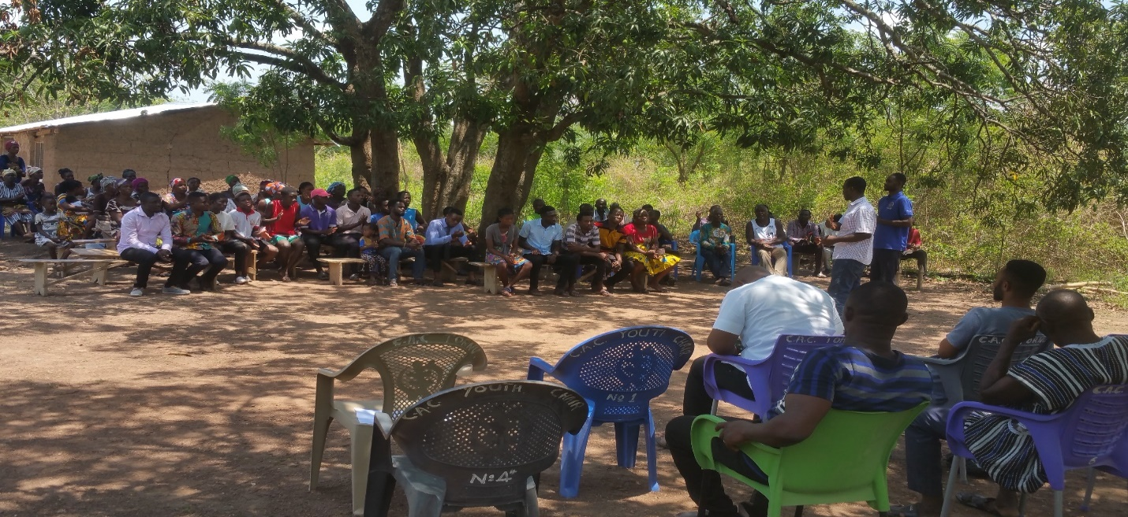
Engagement at Adekope for the Rehabilitation of the Adzekope Feeder Road under the GPSNP

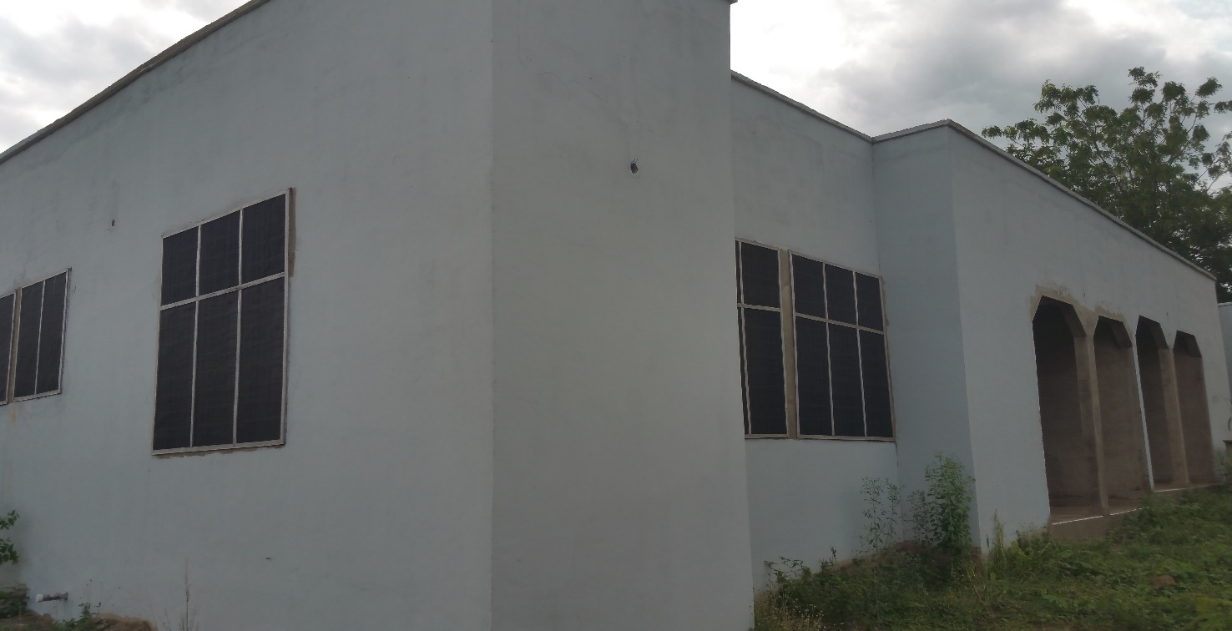
A Two-bedroom Semi-Detached Nurses Quarters at Ve-Golokwati

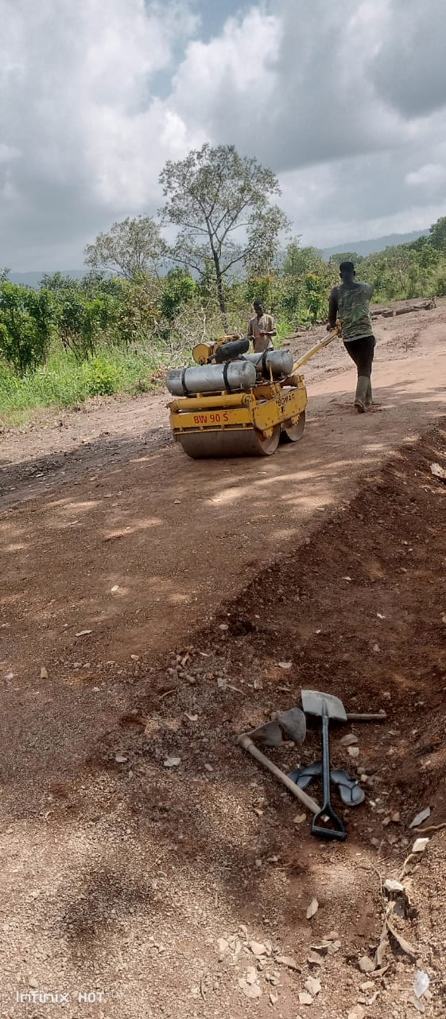
On-going Adzekope Feeder Road Rehabilitation – GPSNP

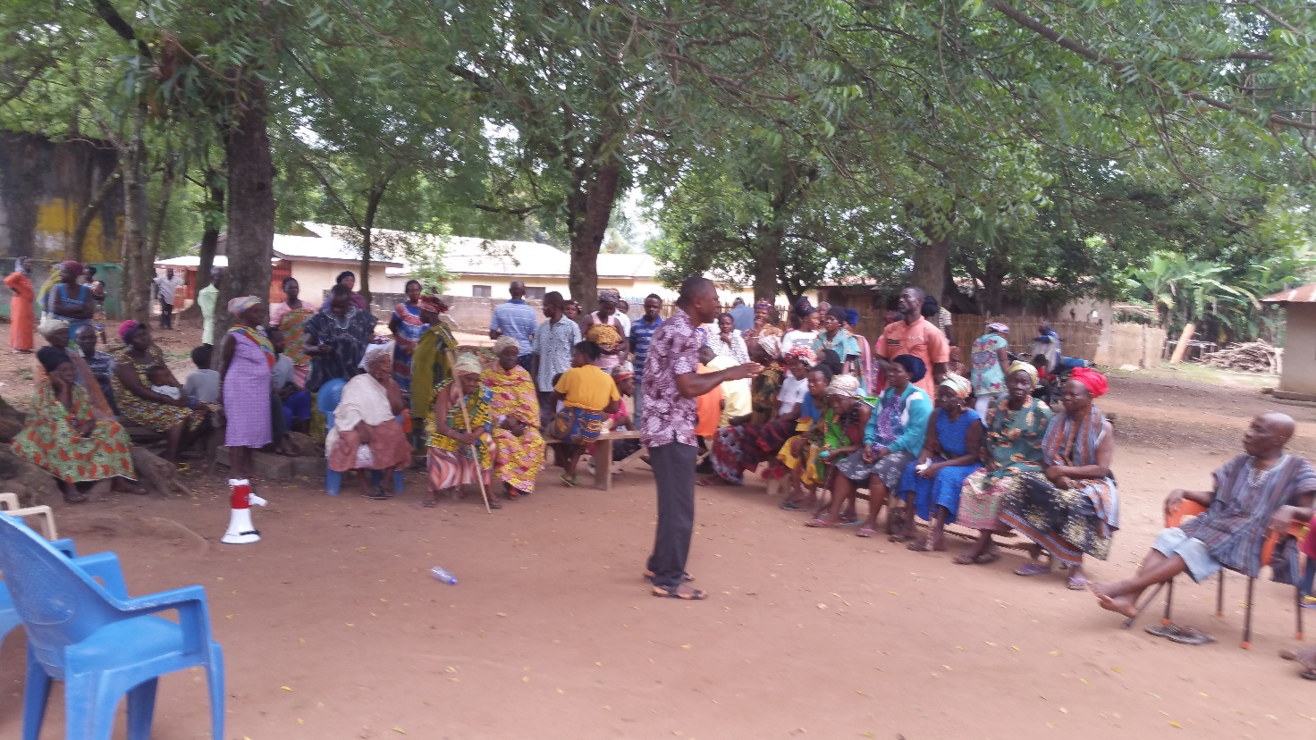
Engagement with Women Farmers at Ve-Agbome

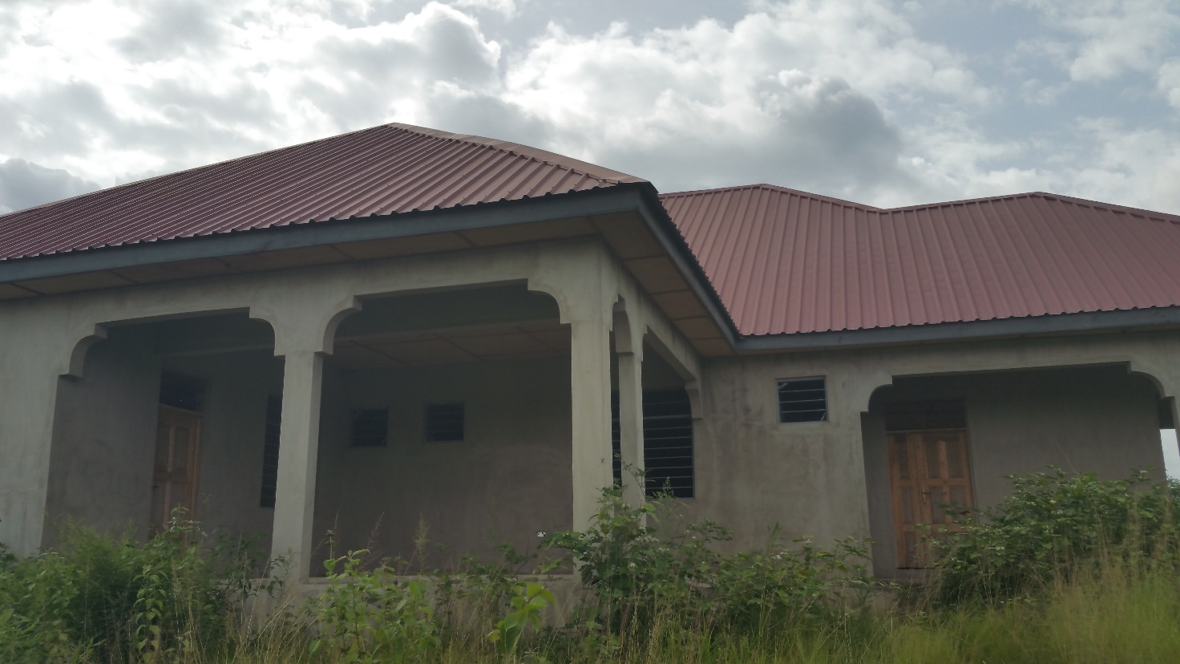
Construction of 1No. 4 bedroom Quarters for District Coordinating Director – Ve Golokwati

